Email Integration to eZnetCRM User Manual
Version: 1.0
Document Information and Approvals
UTORS

Version History
Version # | Date |  | Revised By | Reason for change
1.0 | 05/04/2015

This document has been approved as the official User Manual for Email Integration to eZnetCRM and accurately reflects the working of the application. Following approval of this document, requirement changes will be governed by the project’s change management process, including impact analysis, appropriate reviews and approvals.

Document Approvals
Approver Name | Project Role |  | Signature/Electronic Approval | Date
Manoj Singh | Project manager |  |  | 05/08/2015

1. Document Purpose
This user manual covers of the working of Email Integration to eZnetCRM. It will be used for the following purpose:
- User should be able to alter basic Email Settings ,
  - Add New Email account: When this happens the email account that has been entered into the CRM will sync with the CRM. This allows the user to check email within the CRM itself.
  - Edit existing email account and it’s credentials
  - Mark as default email address
  - Deleting email account
- View Emails: on the currently activate email address
  - Displays a list of all Emails received
  - Reply: Loads a compose instance on the same screen allowing the user to compose and view the email at the same time
  - Forward: Opens up Compose and fills the blank page with the message that the user wishes to forward
  - Delete: Deletes or does not delete message based on input
- Compose an Email
  - There should be a Compose button that pops up a standard email writing box with these functionalities:
    - Bold
    - Italic
    - Underline
    - Font Color
    - Font Size
    - Font Style
    - Link
    - Attach File
    - Insert
    - Photo
    - Alignments
    - Bullet
    - Numbering
- Drafts
  - Delete
  - Compose: User presses compose and it loads the draft in Compose
- Trash Can: Everything that the user deleted goes in here
  - Delete: User can check multiple files.
- Sent Emails
- Spam Emails
- Contact List: A user should be able to right click/hover on any email address that is not currently in their eZnetCRM contact list and add them to it.
  - Add New Contact: This allows the user to type in:
    - First Name
    - Last Name
    - Email Address
    - Nickname
  - Edit existing Contact: This allows the user to type in:
    - First Name
    - Last Name
    - Email Address
    - Nickname

2. Document Resources

Name | Business Unit | Role
Amit Aggarwal | QA Department | QA Engineer
Shravan Kumar | Development | Sr. Software Engineer
Sanjeev Singh | Development | Software Engineer
Manoj Singh | Project Management | Project Manager

3. Glossary of Terms

Term/Acronym | Definition
a/c | Account

4. Landing Page and Login

4.1 Landing Page
The landing page will be opened as soon as the valid URL is initiated by the user. The valid URL will be updated once eZnetCRM team confirms on the domain name.

The landing page screenshot is as follows:

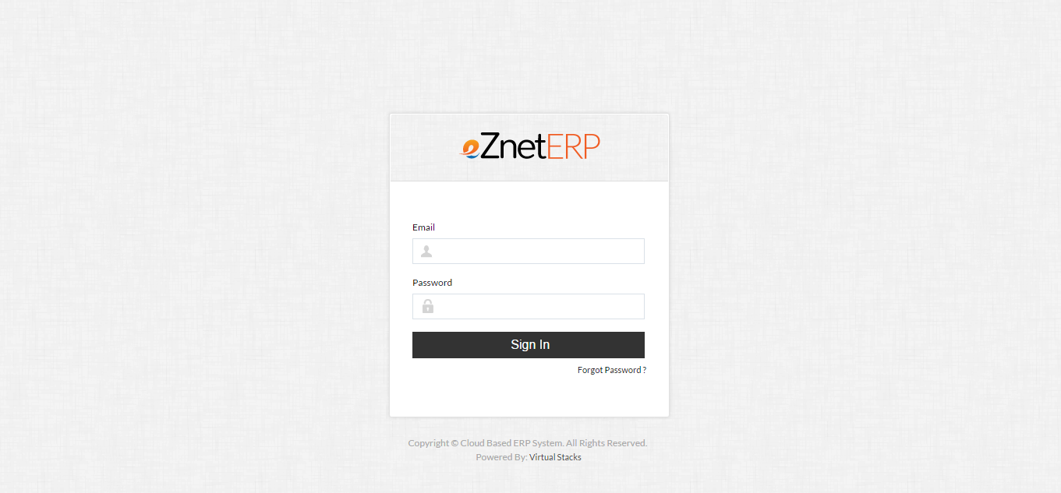

4.2 Login Process
The users from eZnetCRM will be provided user accounts to access the eZnetCRM application. The users list to whom the login accounts need to be configured will be finalized and provided by eZnetCRM.

The authorized user will have unique set of username (email id)/password which will allow her/him to login to user dashboard. The login screen is part of the landing page.

5. User Dashboard

5.1 User Dashboard
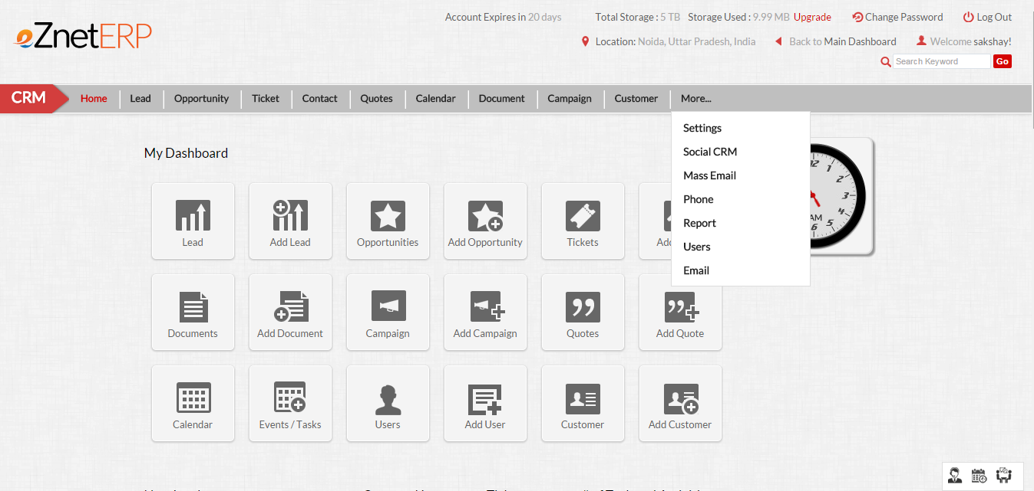

On the user dashboard, the user gets access to following sections based on the access permission level of that user:
- Home
- Lead
- Opportunity
- Ticket
- Contact
- Quote
- Calendar
- Document
- Campaign
- Customer
- More..
  - Settings
  - Social CRM
  - Mass Email
  - Phone
  - Report
  - Users
  - Email

5.2 Email Dashboard
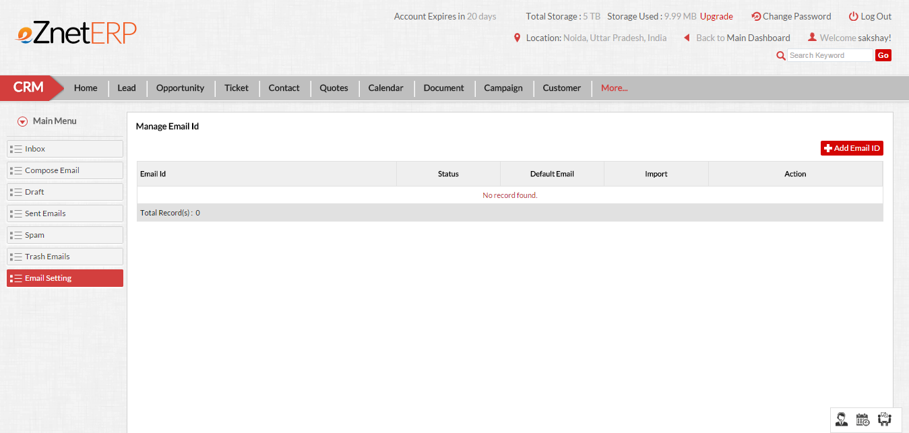

6. Email settings

6.1 Add email account
To add a new email user should need to perform the following steps:

- Go to email from the CRM top navigation refer sec 5.2
- Now click on Email Setting from left navigation
- Now Click on Add email button
- Fill all the required fields
- Also Select Email Server
- If email server is other then please enter two more fields:
  - IMAP Url
  - SMTP Url
- In Case email server is Gmail then we need to perform some settings in our Gmail account that are as follows:
  - INSTRUCTIONS:
Before Importing Emails from gmail:
Please enable IMAP and less secure options in GMAIL Account.
Enable IMAP:
Step 1: Login in Gmail and click on icon which is situated top right corner of window.
Step 2: Now click on setting.
Step 3: Now click on Forwarding and POP/IMAP tab.
Step 4: You will get IMAP Access: and Enable IMAP
Enable less secure options :
Step 1: Open the url: https://www.google.com/settings/security/lesssecureapps or Click here
Step 2: You will get Access for less secure apps and make Turn On
- Click on Submit.
Screen-shots of Steps of adding a new email account are as follows:
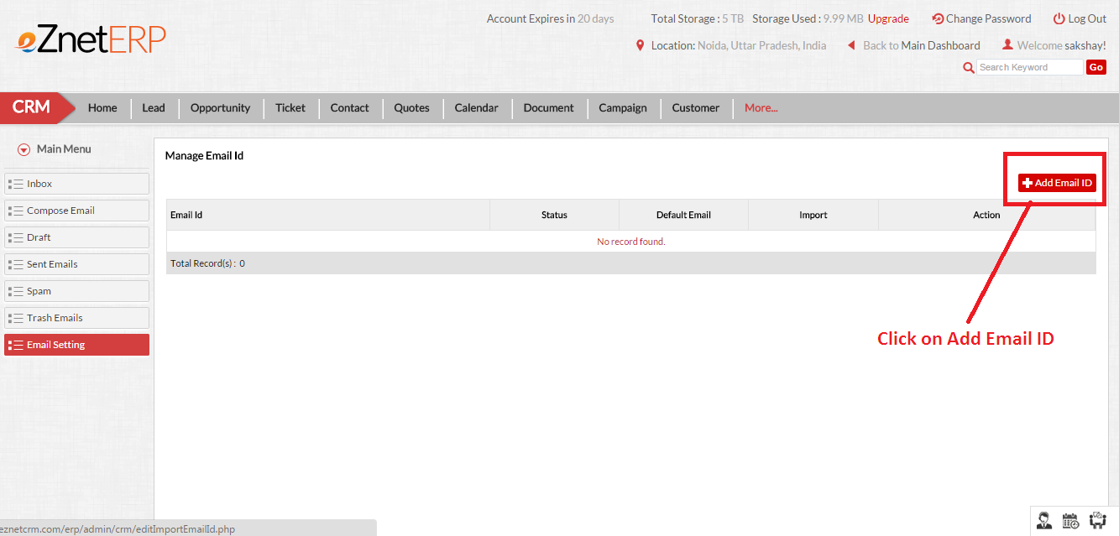

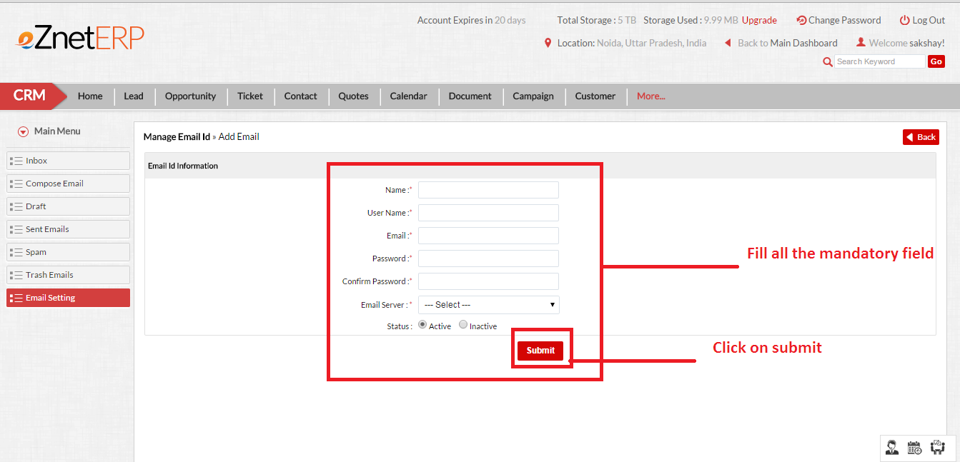

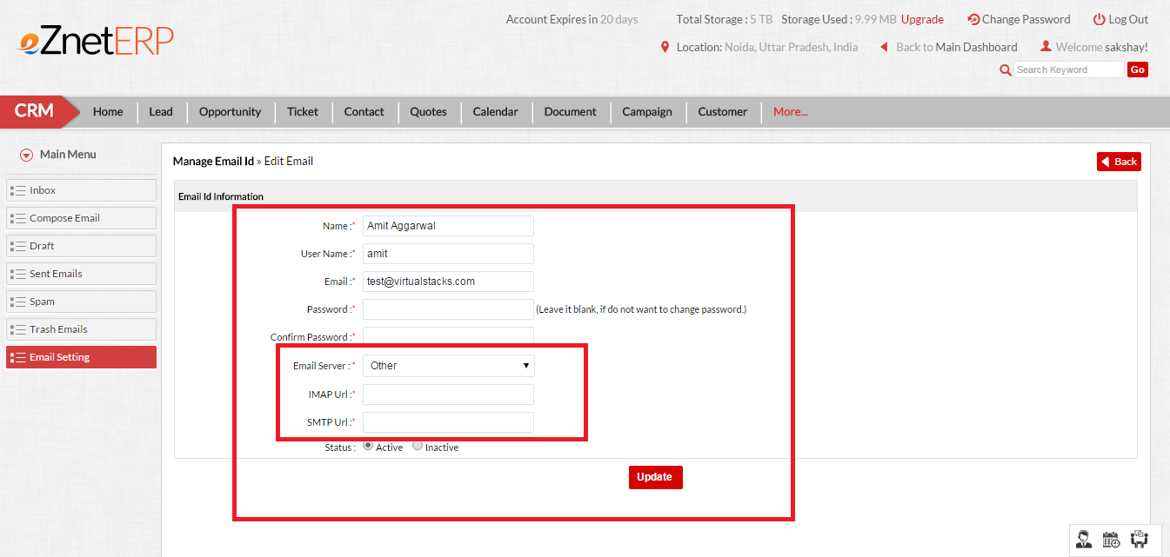

6.2 Edit email account
To edit an existing email account user should need to perform the following steps:

- Go to email from the CRM top navigation refer sec 5.2
- Now click on Email Setting from left navigation
- Now Click on edit email button from the list of emails
- Fill all the required fields/ change the details
- Click on update.
Screen-shots of Steps of updating an existing email account are as follows:
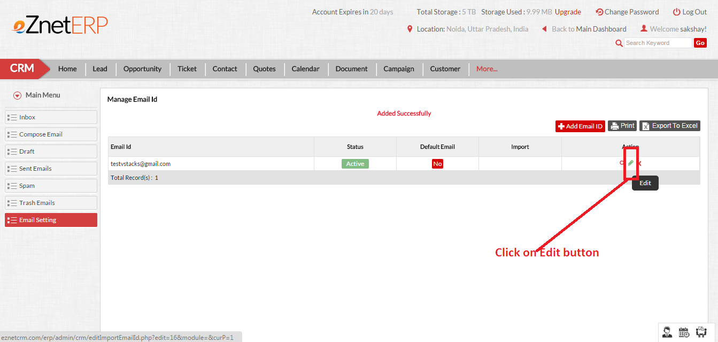

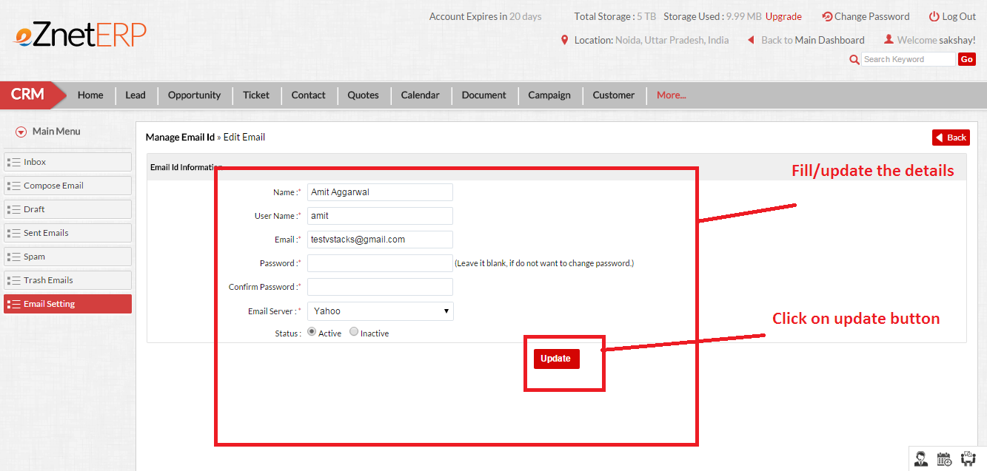

6.3 Mark as default email address
To Mark as default email address user should need to perform the following steps:

- Go to email from the CRM top navigation refer sec 5.2
- Now click on Email Setting from left navigation
- Now Click on No button below the Default email column from the list of emails to whom you want you want to make the email as default.
- Once Clicked your default email will be set to this email ID.

Screen-shots of Steps of mark as default email address are as follows:

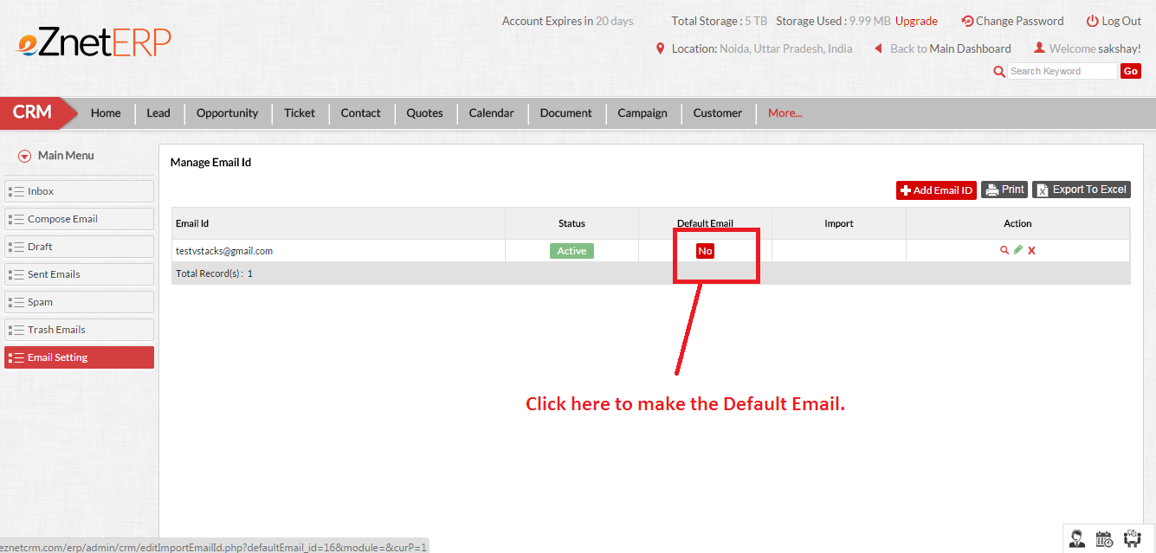

6.4 Delete email account
To delete an existing email account user should need to perform the following steps:

- Go to email from the CRM top navigation refer sec 5.2
- Now click on Email Setting from left navigation
- Now click on delete email button from the list of emails.
- Click on Ok on delete popup.
- Now your email account is get deleted from listing.

Screen-shots of Steps of deleting an email account are as follows:
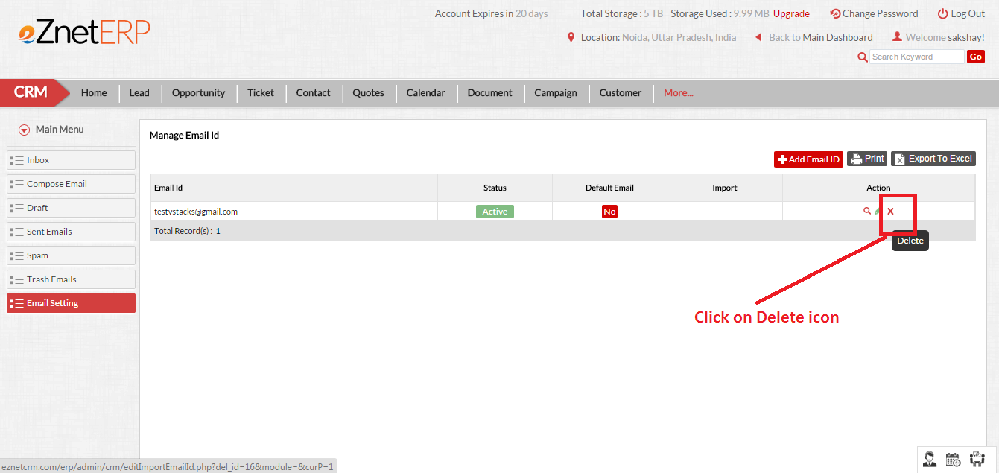

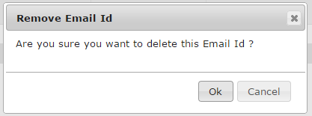
7. View Emails

7.1 View email account
To add a new email user should need to perform the following steps:

- Go to email from the CRM top navigation refer sec 5.2
- Now click on Email Setting from left navigation
- Now Click on Import button from the default email.
- Now click on View Email/Inbox.

Kindly Note: Before going to view email/Inbox Please make sure that you should have at least one default email.

Screen-shots of Steps of View Email are as follows:
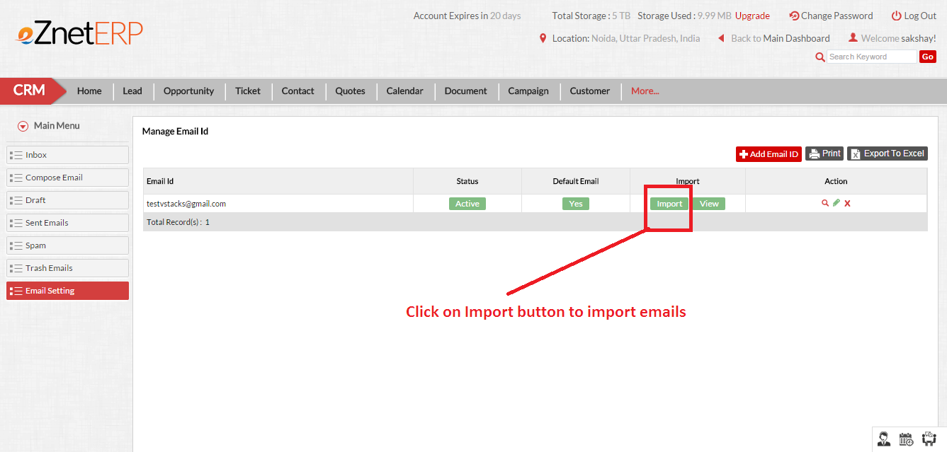

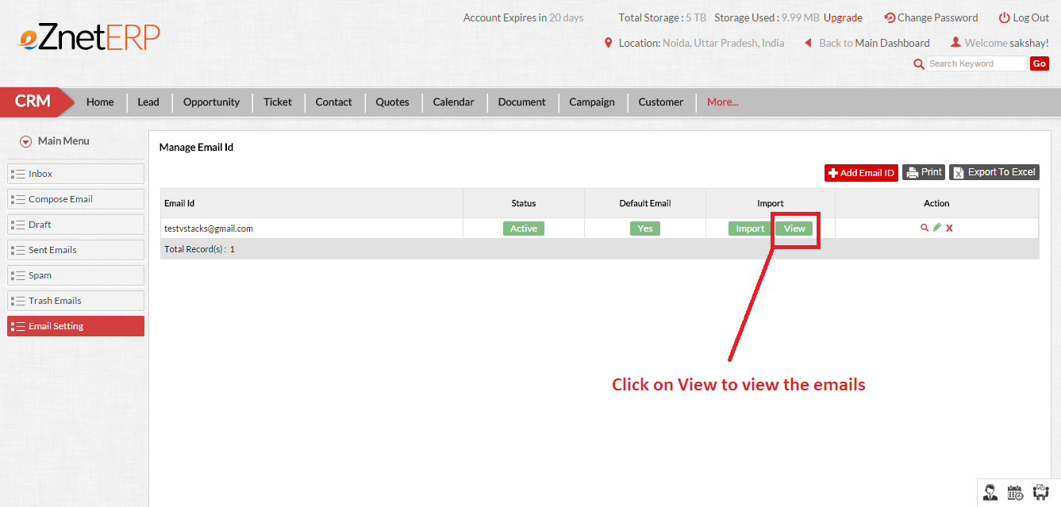

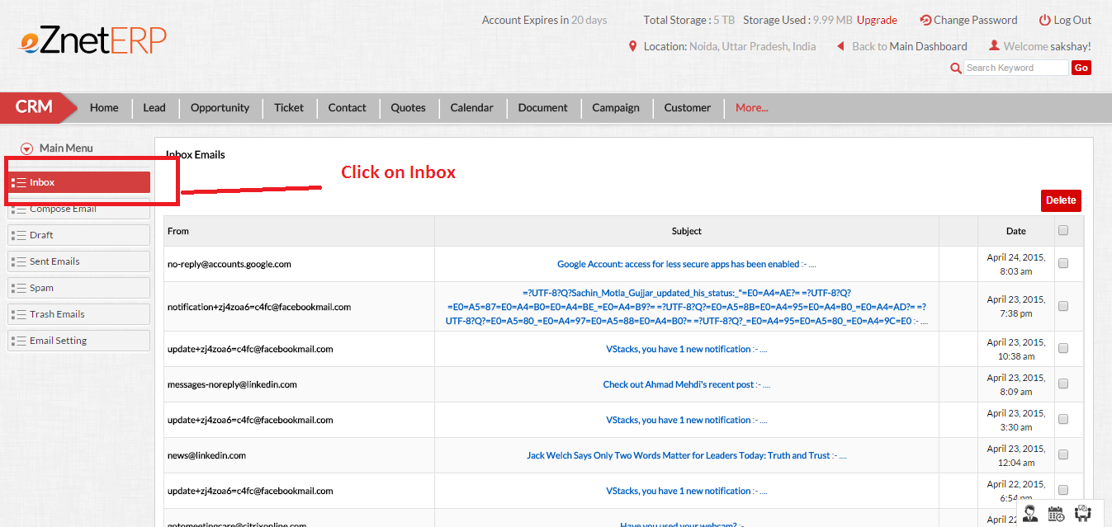

7.2 Deleting the emails from Inbox
To Deleting the emails from Inbox user should need to perform the following steps:

- Go to email from the CRM top navigation refer sec 5.2
- Now click on Inbox from left navigation
- Now selects the emails.
- Click on Delete button.
Screen-shot of Steps of deleting the inbox emails are as follows:

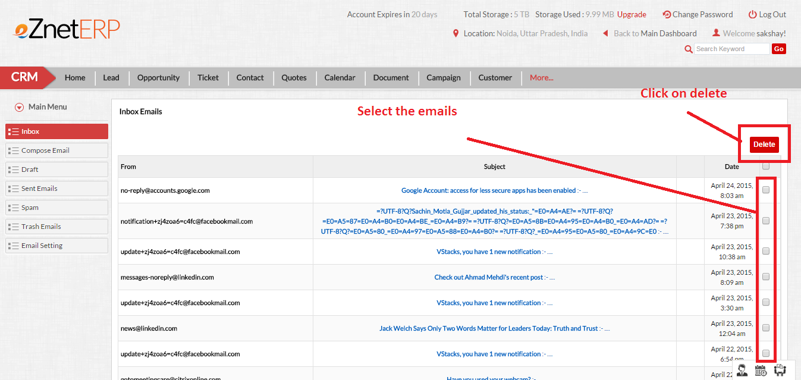

7.3 Reply the email from Inbox
To reply the email from Inbox user should need to perform the following steps:

- Go to email from the CRM top navigation refer sec 5.2
- Now click on Inbox from left navigation
- Now select & open any email.
- On the top there is a button to reply click on it.
- Now your email will be open in the compose email module.
- Click on send button to send a reply or save as draft if you want to send it later on.
Screen-shots of Steps of reply the email from inbox are as follows:

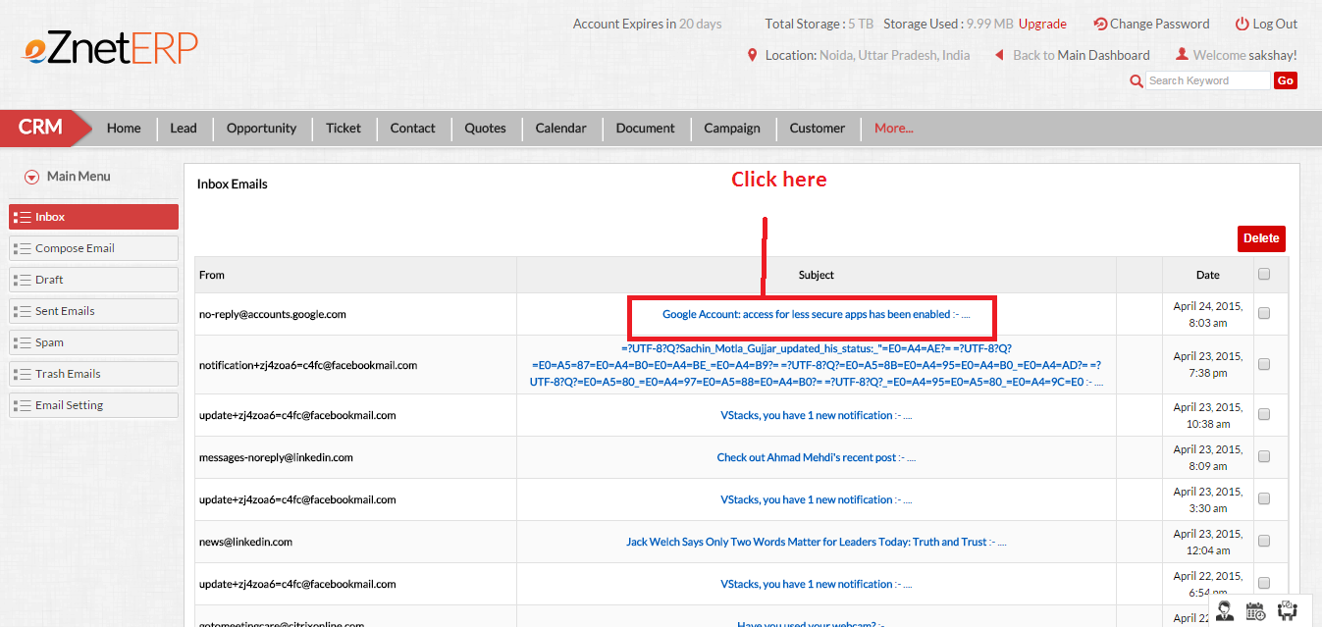

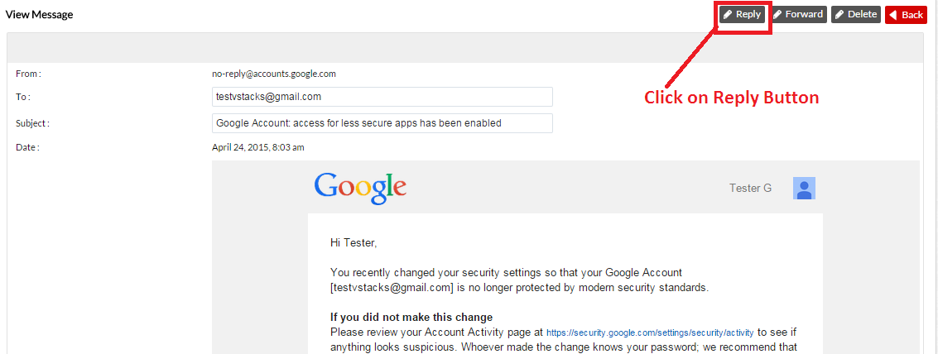

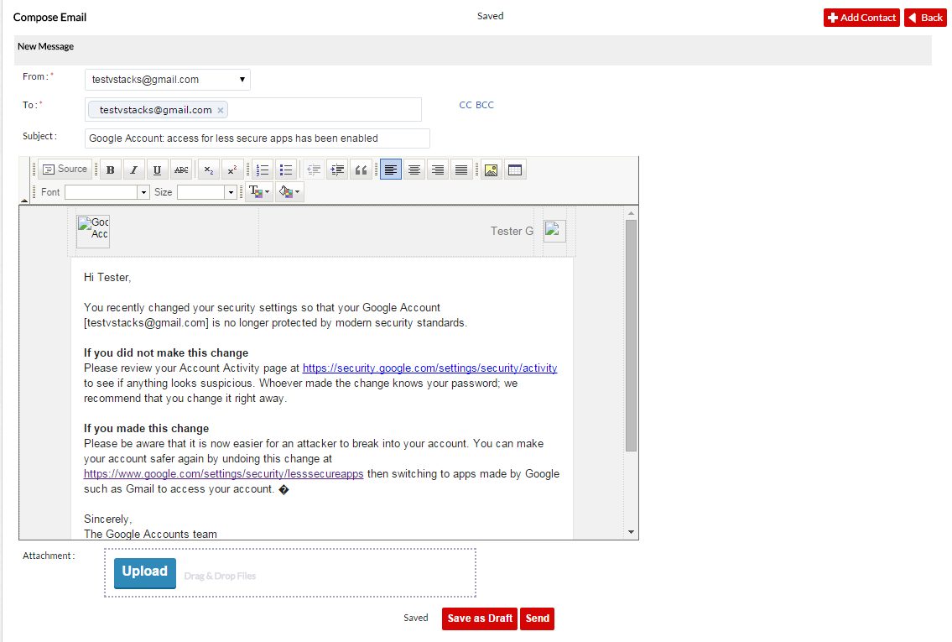

7.4 Forward the email from Inbox
To forward the email from Inbox user should need to perform the following steps:

- Go to email from the CRM top navigation refer sec 5.2
- Now click on Inbox from left navigation
- Now select & open any email.
- On the top there is a button to forward click on it.
- Now your email will be open in the compose email module.
- Click on send button to forward the email or save as draft if you want to send it later on.
Screen-shot of Steps of forward Email is as follows:

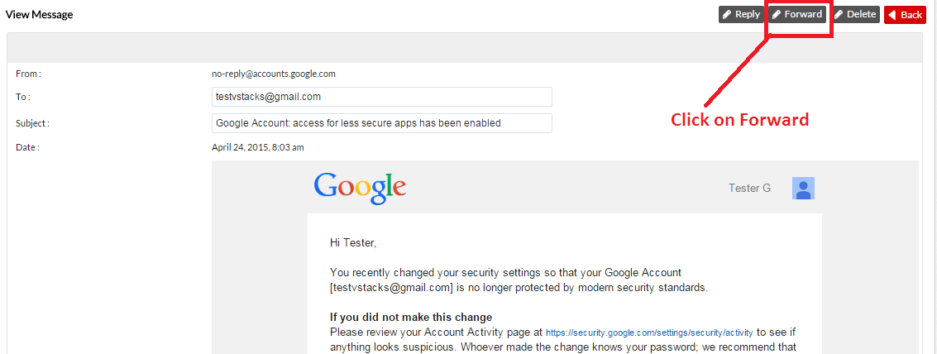
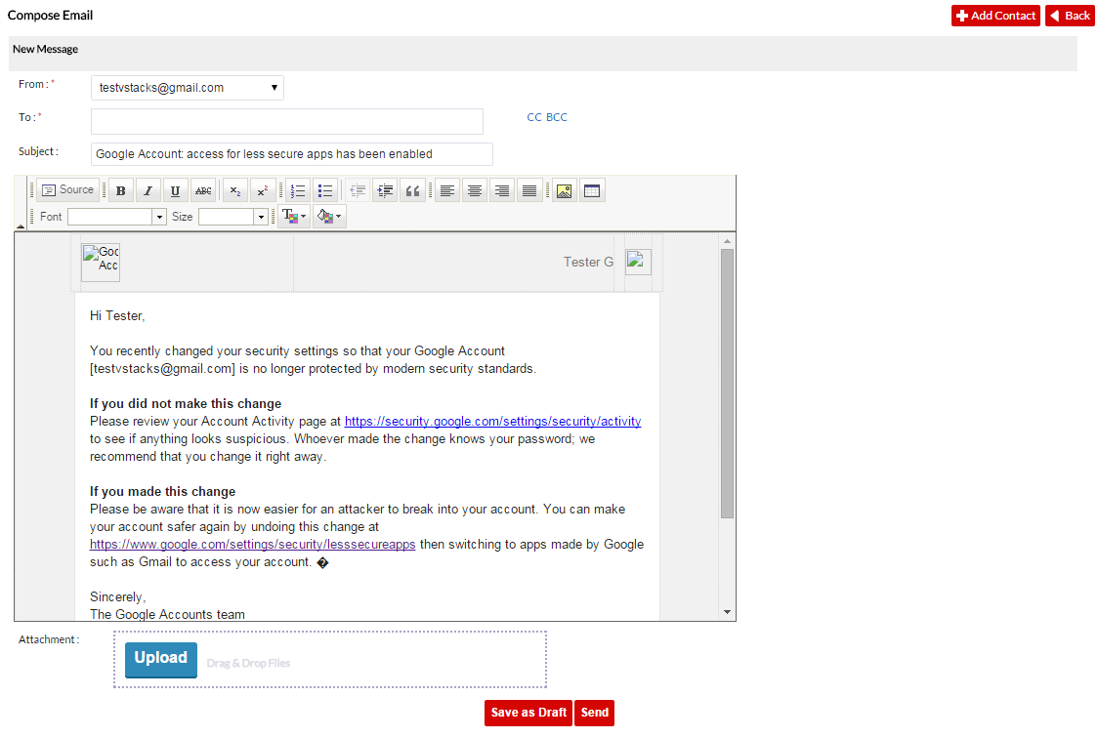

7.4 Delete the email from Inbox
To delete the email from Inbox user should need to perform the following steps:

- Go to email from the CRM top navigation refer sec 5.2
- Now click on Inbox from left navigation
- Now select & open any email.
- On the top there is a button to delete click on it.
- Now it confirms to delete. Click on Ok to delete.

Screen-shot of Steps of Deleting Email from inbox is as follows:

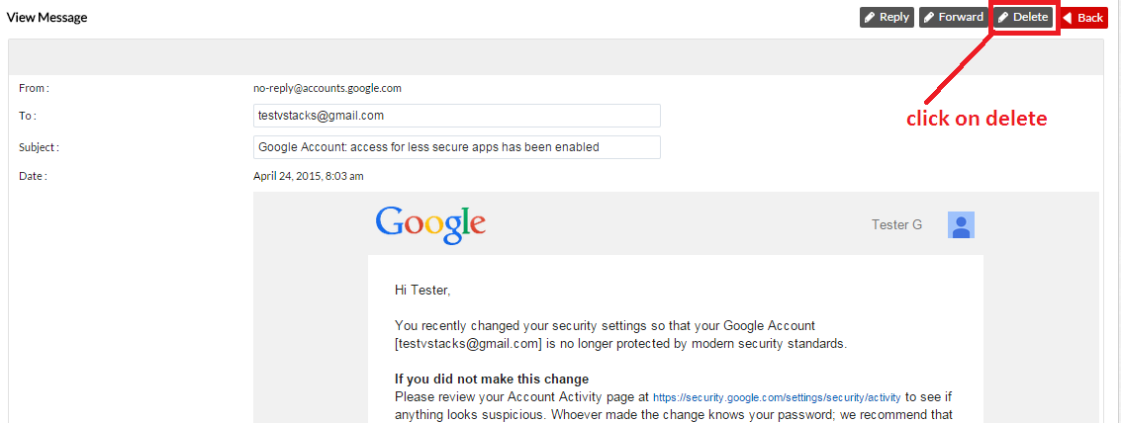

8. Compose Email

8.1 Compose New Email
To add a new email user should need to perform the following steps:
- Go to email from the CRM top navigation refer sec 5.2
- Now click on Compose Emails from left navigation
- Now Click on Import button from the default email.
- Now click on compose email.
- Fill all the mandatory Fields.
- Here an editor with all below function will appear:
  - Bold
  - Italic
  - Underline
  - Font Color
  - Font Size
  - Font Style
  - Link
  - Attach File
  - Insert
  - Photo
  - Alignments
  - Bullet
  - Numbering
- Compose your email & if you want to send it later on then click on Save as draft or you can send it by clicking on Send.
Kindly Note: Before going to compose email Please make sure that you should have at least one default email.
Screen-shots of Steps of Compose Email are as follows:

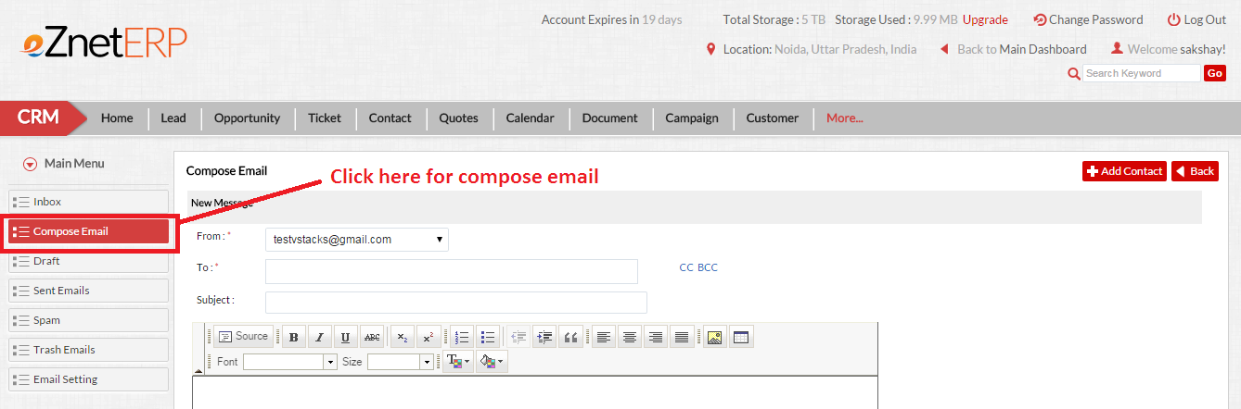
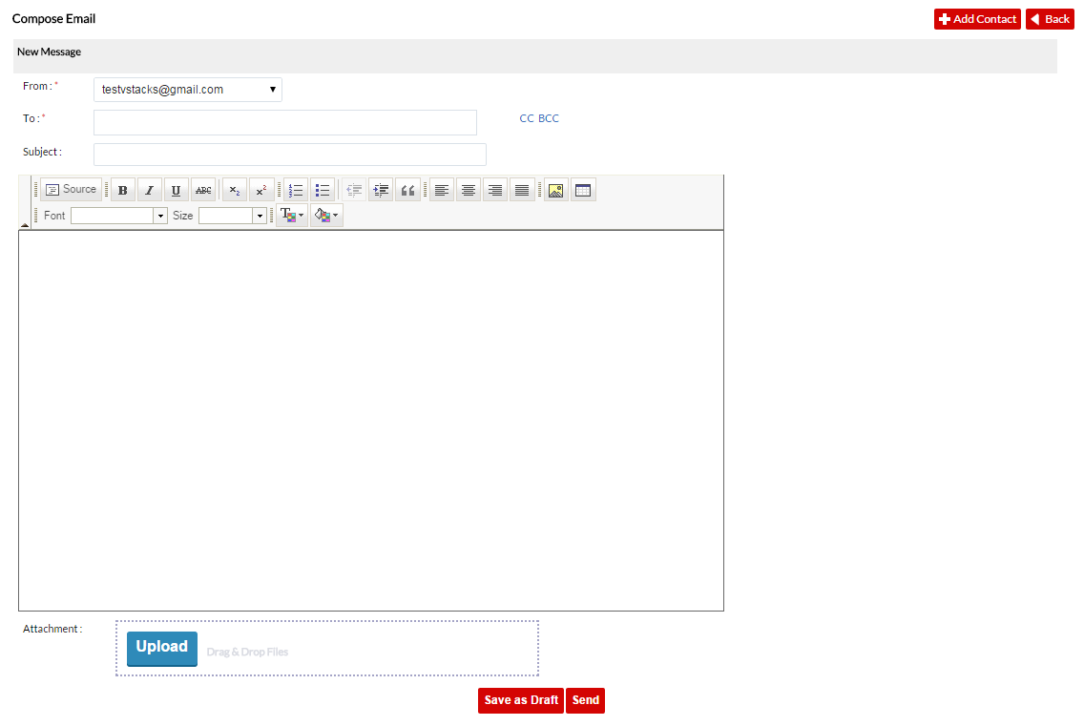
9. Drafts Email

9.1 Drafts Email
To view Drafts email user should need to perform the following steps:
- Go to email from the CRM top navigation refer sec 5.2
- Now click on Draft from left navigation
- Now a new page appeared, Click on any email to view that email.
- After clicking on email you can edit / delete or send the previously saved emails.

Screen-shots of Steps of Draft Email are as follows:

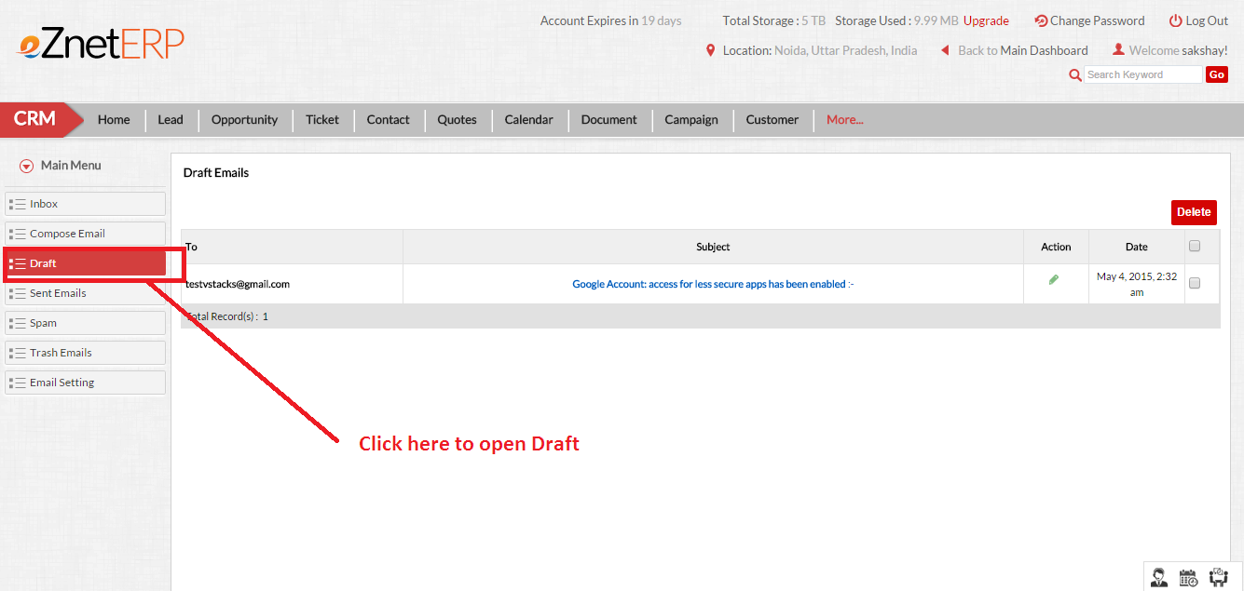

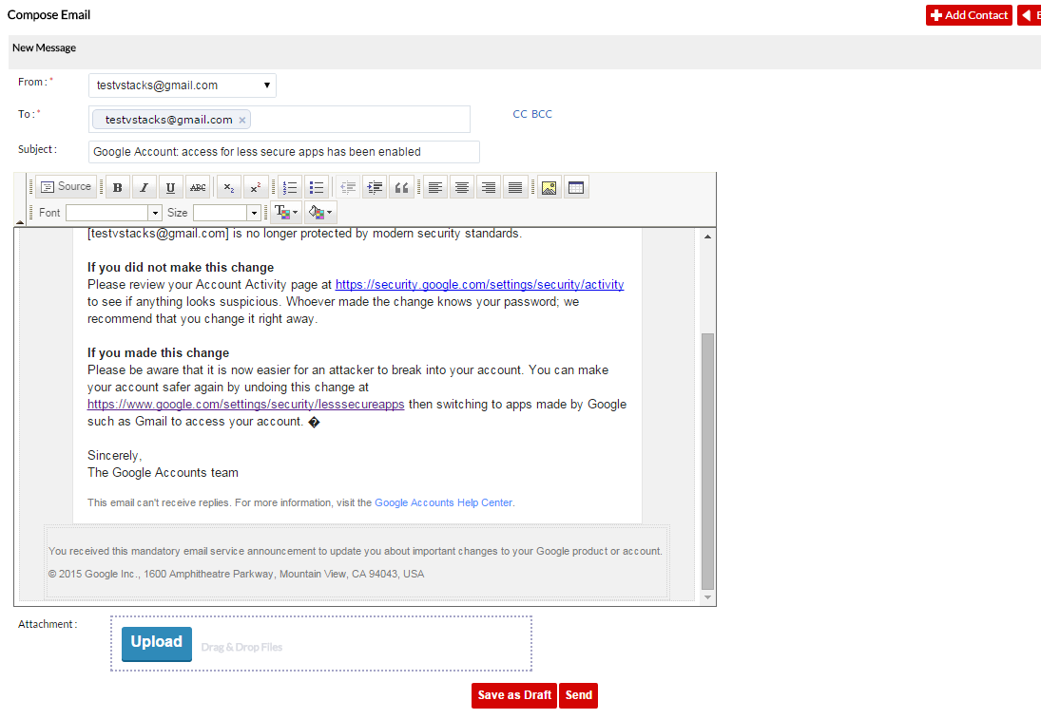
10. Trash Emails

8.1 Trash emails
To view emails in trash user should need to perform the following steps:
- Go to email from the CRM top navigation refer sec 5.2
- Now click on Trash Emails from left navigation
- Now a page will appear here you can see all the deleted emails.
- Click on any email to view.
- From that page you can reply/forward or permanently delete your email from the eZnetCRM.

Screen-shots of Steps of Draft Email are as follows:
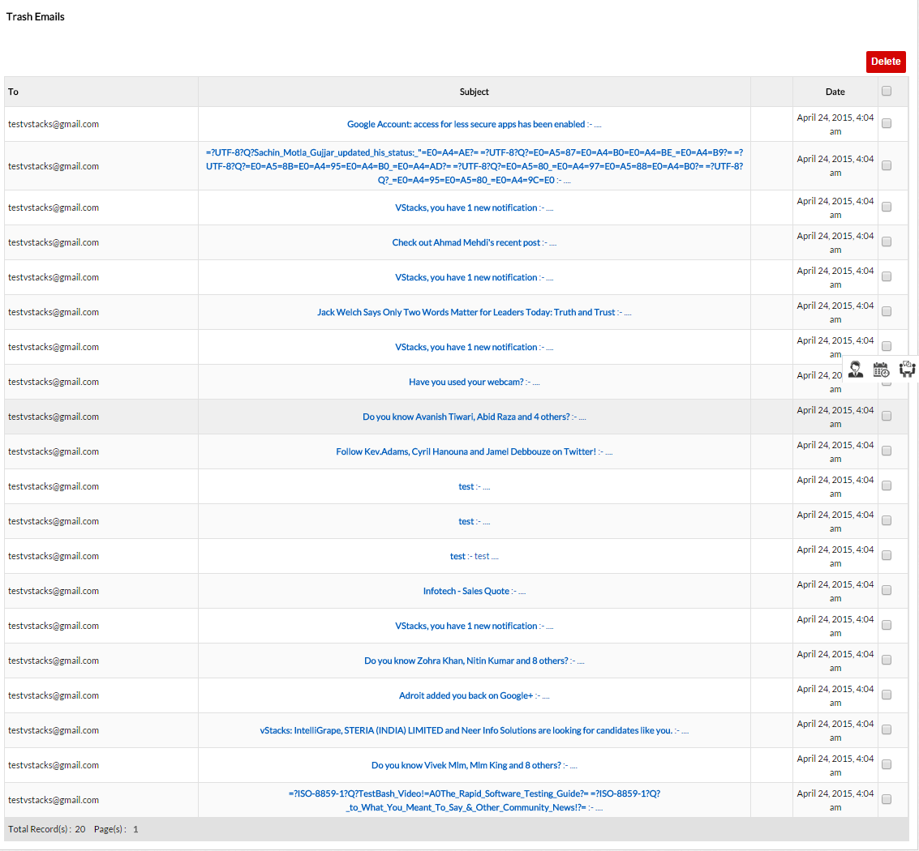

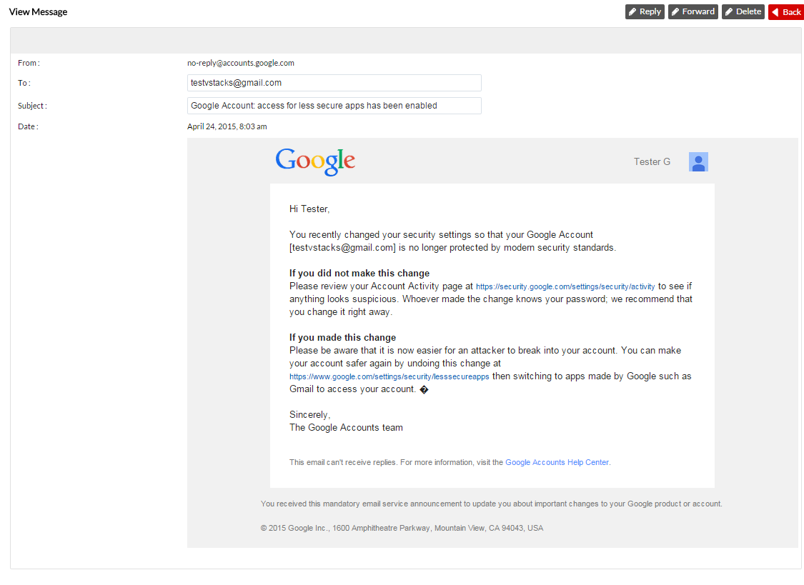
11. Sent Emails

11.1 Sent emails from eZnetCRM
To view emails in Sent emails user should need to perform the following steps:
- Go to email from the CRM top navigation refer sec 5.2
- Now click on Sent Emails from left navigation
- Now a page will appear here you can see all the Sent emails from eZnetCRM.
- Click on any email to view. Now you can see the email which is sent by you using eZnetCRM.
- From that page you can reply/forward or delete your email from the eZnetCRM.

Screen-shots of Steps of Sent Email are as follows:

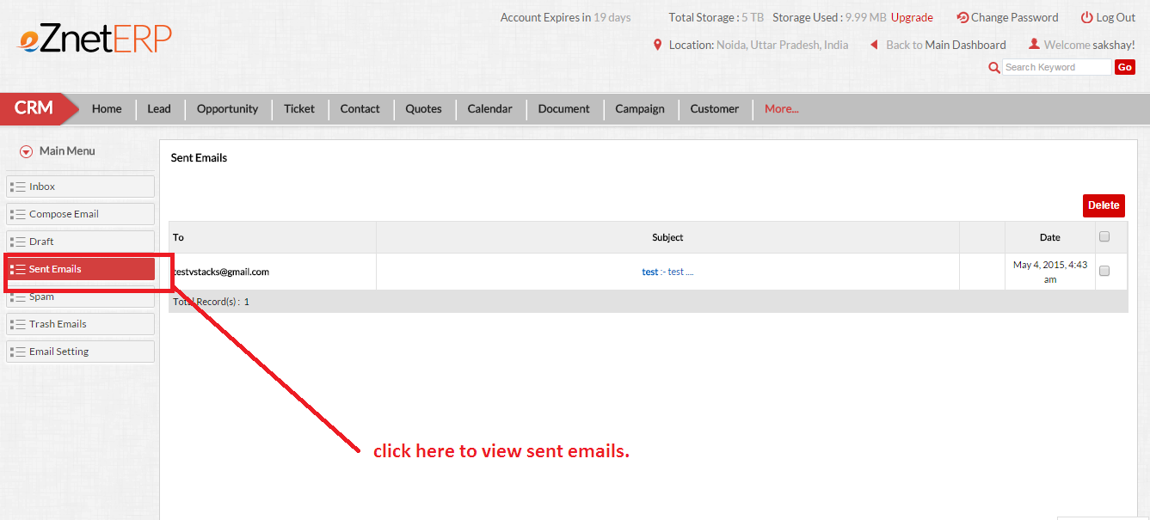

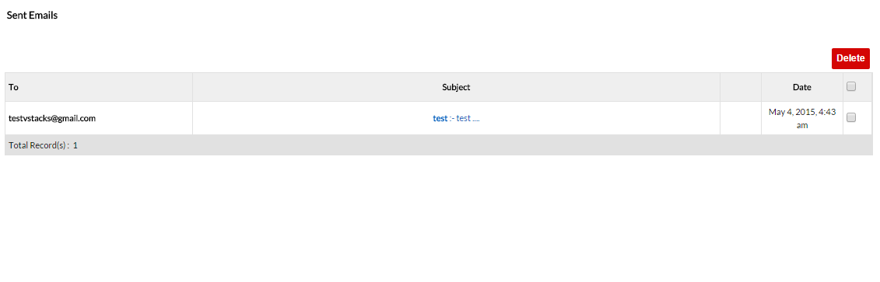
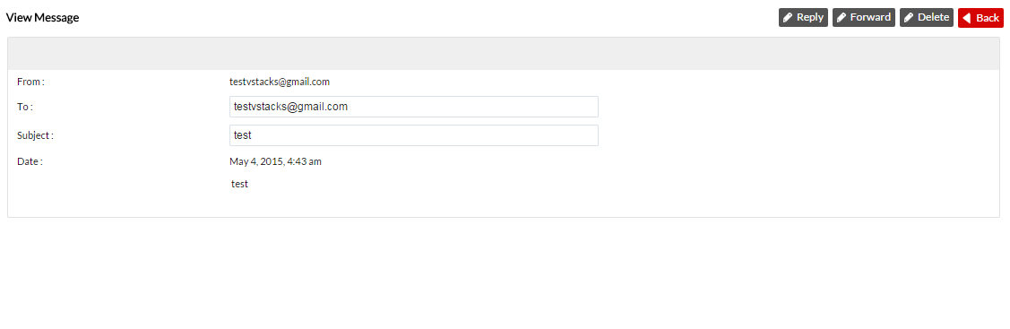
12. Spam Emails

12.1 Spam emails from eZnetCRM
To view Spam emails user should need to perform the following steps:
- Go to email from the CRM top navigation refer sec 5.2
- Now click on Spam Emails from left navigation
- Now a page will appear here you can see all the spam emails in eZnetCRM.
- Click on any email to view. Now you can see the email which is in spam by using eZnetCRM.
- From that page you can reply/forward or delete your email from the eZnetCRM.

Screen-shots of Steps of view Spam Email are as follows:

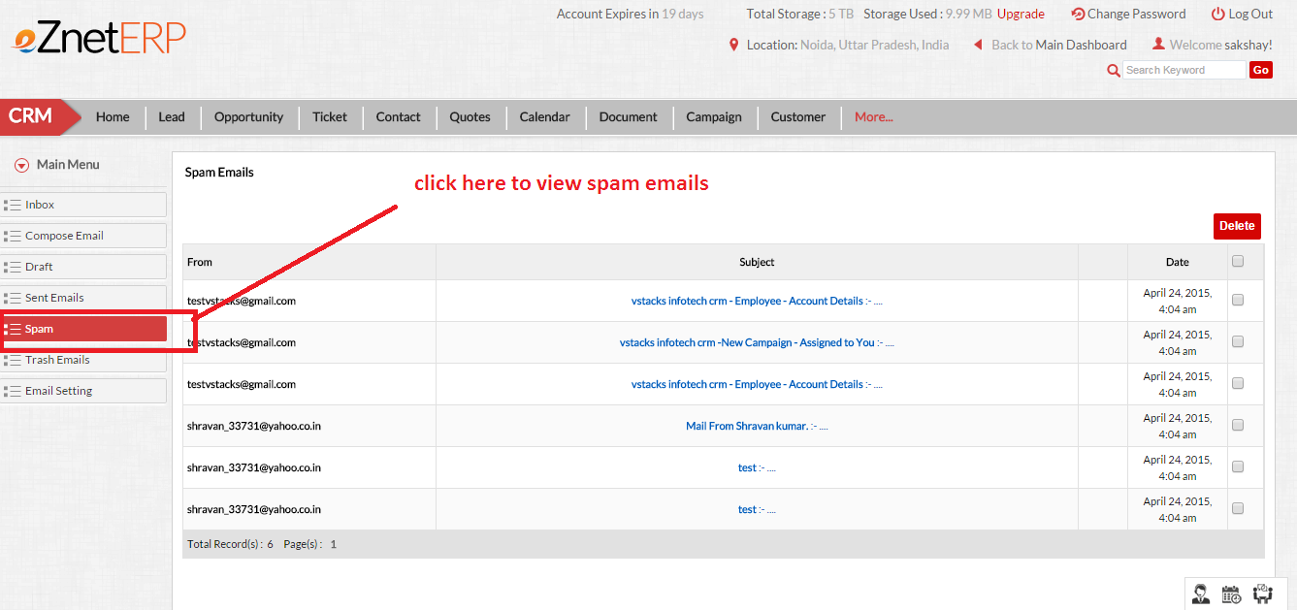

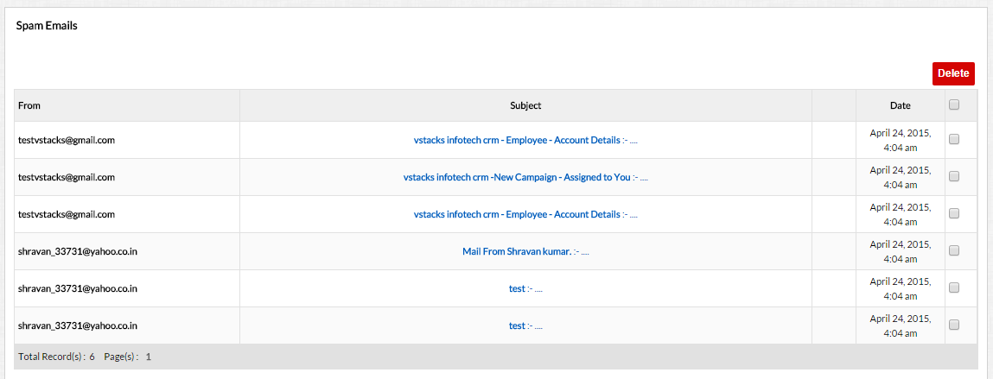
13. Contact List

13.1 Add New Contact/Update Existing Contact
To add new contact/ Update existing contact user should need to perform the following steps:
- Go to email from the CRM top navigation refer sec 5.2
- Now click on any email folder like: Inbox/Trash/Spam/Sent Emails/ Drafts from left navigation
- Now a page will appear here you can see all the listings of emails in eZnetCRM.
- On any of these email when we hover or right click then a small popup appears. Now you can click on the add/edit contact.
- After clicking on it a new form will be opened in popup/user contact details will be shown on the popup and from here you can add/update any contact. Fill all the mandatory fields and click on submit to save the contacts.

Screen-shots of Steps of Add/edit contacts are as follows:
